# Laboratory 3

1. Questions
   1. Write a program to find biggest among three numbers using pointer.
   2. Write a program to find the sum of all the elements of an array using pointers
   3. Write a program to sort a list of string words using an array of pointers.

1. Algorithm

**2.1 a program to find biggest among three numbers using pointer.**

Step1: start

Step2: input the numbers

Step3: void max(int *n,int l){

   int max_num = *n,i=0;

Step4: while (i<l) {

    if (*n>max_num) {

      max_num = *n;

    }

    n++;

    i++;

  }

Step5:   print max_num

Step6: stop

**2.2 a program to find the sum of all the elements of an array using pointers**

Step1: start

Step2: input no. of element

Step3: input elements

Step4: int add=0;

for ( int i = 0; i < k; i++){

add+=(*p);

p++;

}

Step5: print add

Step6: stop

**2.3 a program to sort a list of string words using an array of pointers.**

Step1: start

Step2: input string

Step3: char temp[10];

strcpy(temp," ");

Step4: for (int i = 0; i < 5; i++) {

for (int j = i+1; j < 5; j++) {

if (strcmp(c[i],c[j])>0) {

strcpy(temp,c[j]);

strcpy(c[j],c[i]);

strcpy(c[i],temp);

}

}

}

Step5: print string

for (int i = 0; i <5; i++) {

printf("%s\n",c[i]);

Step6: stop

1. Program

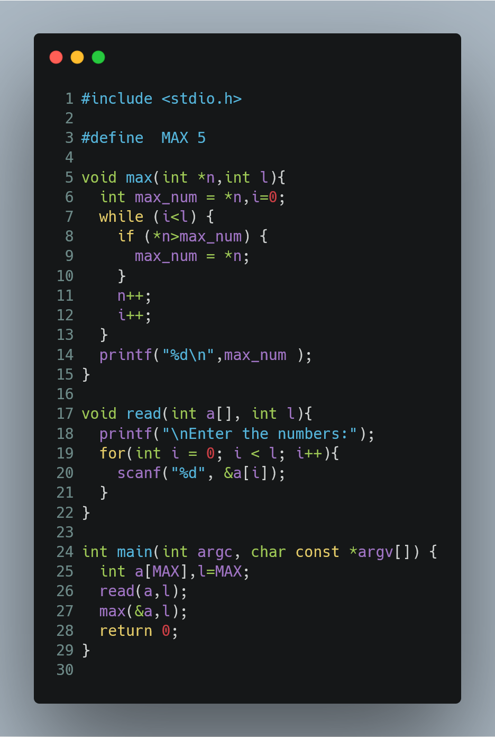

Figure 1 program to find biggest among three numbers using pointer.

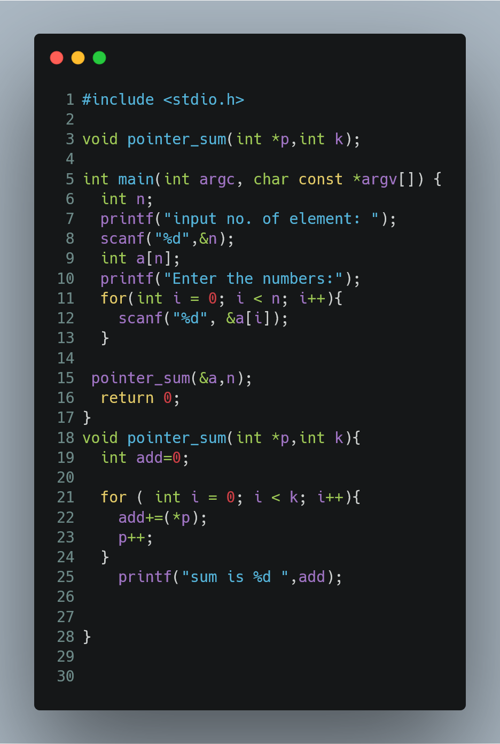

Figure 2 program to find the sum of all the elements of an array using pointers

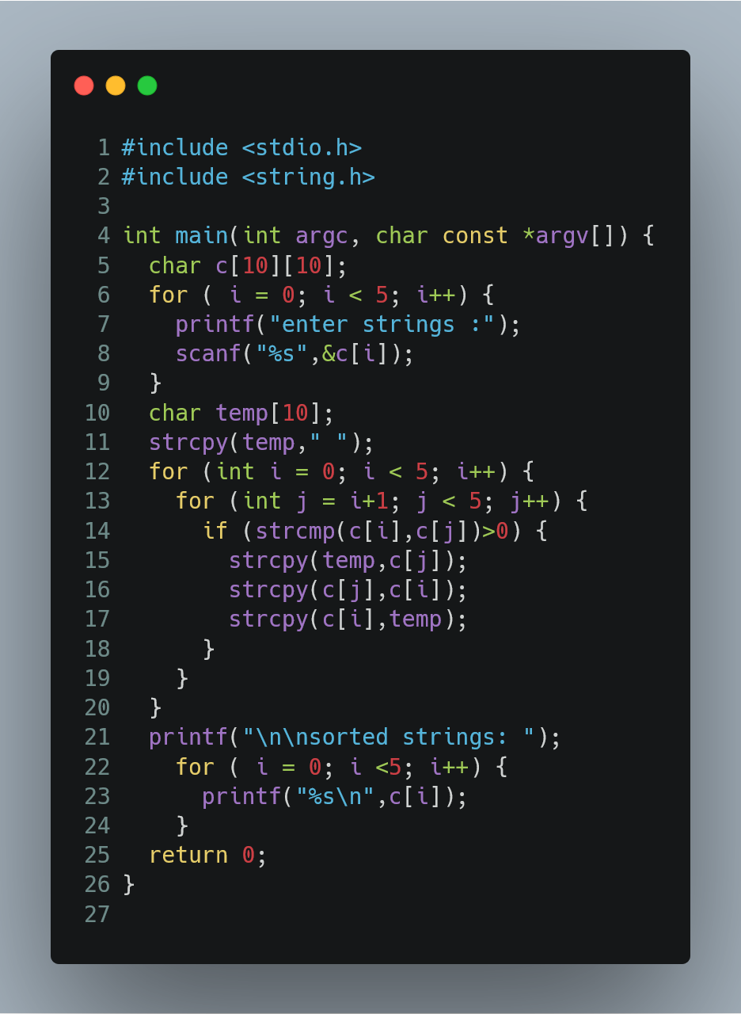

Figure 3 program to sort a list of string words using an array of pointers.

1. Presentation of Results

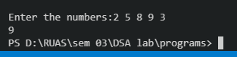

Figure 4 output of program to find biggest among three numbers using pointer

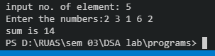

Figure 5 output of program to find the sum of all the elements of an array using pointers

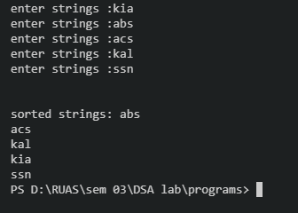

Figure 6 output of program to sort a list of string words using an array of pointers

1. Conclusions

Learning happened:

* To access address of a variable to a pointer, we use the unary operator **&** (ampersand) that returns the address of that variable. For example &x gives us address of variable x.
* To declare a pointer variable: When a pointer variable is declared in C, there must a * before its name.
* To access the value stored in the address we use the unary operator (*) that returns the value of the variable located at the address specified by its operand.

Hence we can see the programs are compiled successfully without any error.